**Case Study: Stakeholder Engagement & Communication Plan**

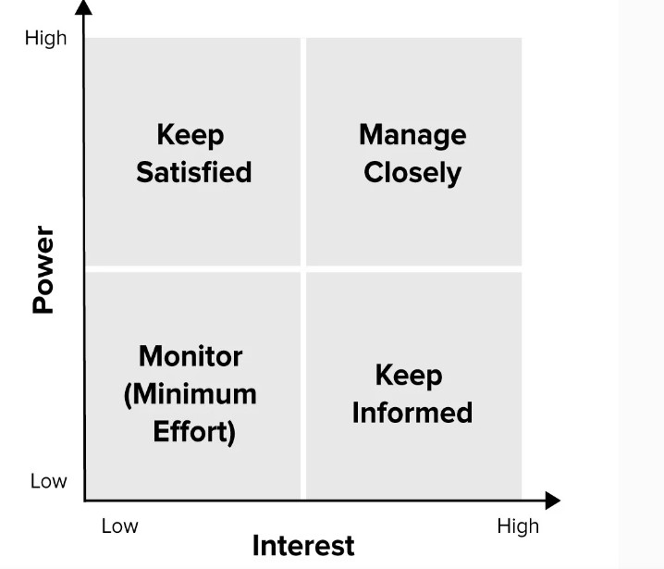

|  |  |  |  |  |  |
| --- | --- | --- | --- | --- | --- |
| Communication | Responsibility | Audience | Medium | Goal | Frequency |
| Project team |  |  |  |  |  |
| Project status report | Project manager | Project team and project sponsor | meeting | Review project status and discuss issues or delays | weekly |
| Team standup | Project management | Project team | meeting | Discuss what each team member did yesterday what they’ll do today and any blockers | daily |
| Project review | Project management | Project team and project sponsor | meeting | Present project deliverables, gather feedback, and discuss next steps | weekly |
| Post-mortem meeting | Project manager | Project team | meeting | Assess what worked and what did not work and discuss actionable takeaways | At end of a project |
| Task progress updates | Project manager | Project team | online | Share daily progress made on projects tasks | daily |
| Project sponsor |  |  |  |  |  |
| Project status report | Project manager |  | meeting | Review project status and discuss potential issues or delays | weekly |
| Project review | Project manager |  | online | Present project deliverables, gather feedback, and discuss next steps | weekly |